|  |
| --- |
| Experiment No.2 |
| Accepting Input Through Keyboard |
| Date of Performance: |
| Date of Submission: |

**Aim:** To apply basic programing for accepting input through keyboard.

**Objective:** To use the facility of java to read data from the keyboard for any program

**Theory:**

Java brings various Streams with its I/O package that helps the user perform all the Java input-output operations. These streams support all types of objects, data types, characters, files, etc. to fully execute the I/O operations. Input in Java can be with certain methods mentioned below in the article.

Methods to Take Input in Java

There are two ways by which we can take Java input from the user or from a file

1. BufferedReader Class
2. Scanner Class

**Using BufferedReader Class for String Input In Java**

It is a simple class that is used to read a sequence of characters. It has a simple function that reads a character another read which reads, an array of characters, and a readLine() function which reads a line.

InputStreamReader() is a function that converts the input stream of bytes into a stream of characters so that it can be read as BufferedReader expects a stream of characters. BufferedReader can throw checked Exceptions.

**Using Scanner Class for Taking Input in Java**

It is an advanced version of BufferedReader which was added in later versions of Java. The scanner can read formatted input. It has different functions for different types of data types.

The scanner is much easier to read as we don’t have to write throws as there is no exception thrown by it.

It was added in later versions of Java

It contains predefined functions to read an Integer, Character, and other data types as well.

**Syntax of Scanner class**

**Scanner scn = new Scanner(System.in);**

**Code:**

import java.io.BufferedReader;

import java.io.IOException;

import java.io.InputStreamReader;

import java.util.Scanner;

public class InputExample {

public static void main(String[] args) {

Scanner scanner = new Scanner(System.in);

BufferedReader bufferedReader = new BufferedReader(new InputStreamReader(System.in));

try {

System.out.print("Enter a line of text using Scanner: ");

String inputScanner = scanner.nextLine();

System.out.println("You entered (using Scanner): " + inputScanner);

System.out.print("Enter another line of text using BufferedReader: ");

String inputBufferedReader = bufferedReader.readLine();

System.out.println("You entered (using BufferedReader): " + inputBufferedReader);

} catch (IOException e) {

e.printStackTrace();

} finally {

scanner.close();

try {

bufferedReader.close();

} catch (IOException e) {

e.printStackTrace();

}

}

}

}

**Output:**

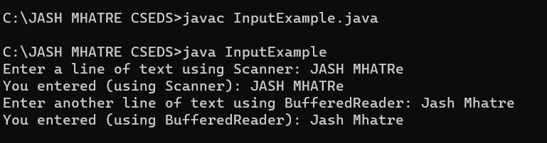

**Conclusion:**

Implementing basic programming for accepting input through the keyboard is a fundamental step in developing interactive and user-friendly software applications Accepting keyboard input is a crucial aspect of engaging users with your software. It enables users to provide data, make selections, and actively participate in the program's execution.Input Collectionmethods can handle various data types, including strings, numbers, and characters.